Marpe Assembly of All Nations

**SUMMER REV 2025 DAY 2 (AFTERNOON SESSION) WORKSHEET**

**BREAKING FREE FROM ALL PRISONS** (DEFINITION AND IDENTIFICATION)

**Prison** **Definition**: Any situation, circumstance or reality, be it spiritual, physical or metaphysical that restrains from movement, expression or any desired activity that is within human and natural laws and godly expressions

These prisons are categorised as; physical, functional, spiritual and metaphysical restraints.

**Physical Prisons** *(actual)*: Actual physical places where people are kept under forced control when serving a criminal sentence after being convicted of a crime in society (Acts 12:6)

**Functional Prisons** *(sicknesses)*: A limitation or complete restraint of the person’s practical function brought about by a disease or sicknesses that may affect any part of their being (Jn 5:3,5-6; Lk 8:43)

**Spiritual Prisons** *(sinfulness)*: Describes a state of unconscious rebellion (sinfulness) without God and His redeeming grace for forgiveness and reconciliation (Jn 12:40; Acts 28:26-27)

**Metaphysical Prisons** *(compromise)*: Describes a state of conscious deviation from God’s standard without power, or willingness to be free and reconciled to God (1Jn 2:15; Mat 6:24; Jm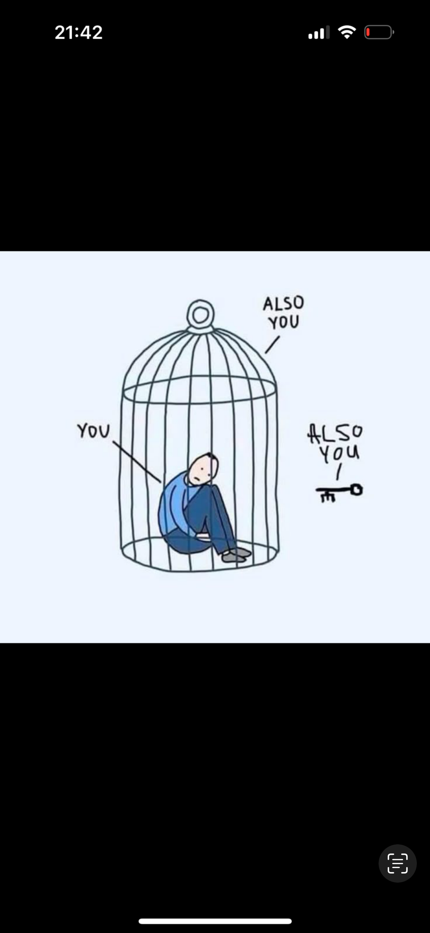 4:4)

**Activity 1 (Personal Reflection)**

1. How would you objectively define your personal prison (if applicable) in view of the above definitions?
2. How did you come by this conclusion?
3. Do you think someone who knows you closely would concur with this analysis of yourself?

**Activity 2 (Group Interaction)**

1. Choose a partner (preferably someone close) ask them if they think you may have fallen into any of the above prisons
2. Ask them how they came to that conclusion
3. In which of the prisons do you think they have fallen?
4. How did you you come by that conclusion?